FEASIBILITY ANALYSIS

(Moodle Discussion Portal)

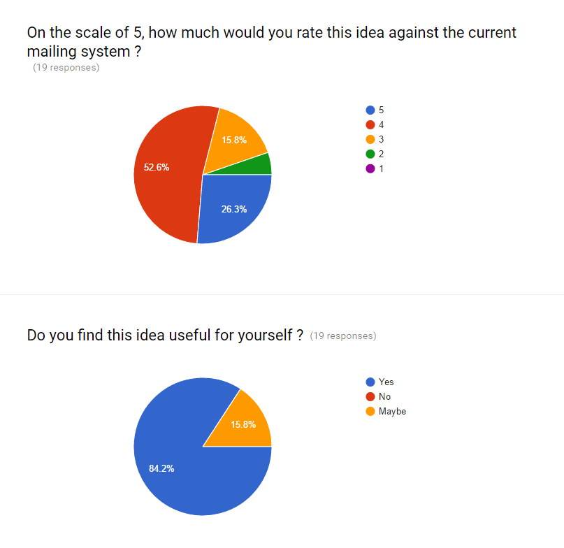

This feasibility study is for a Web-based application to share assessment results, resources, and methodologies on academic credential assessments.

We have got reviews from people of our university itself, since it is related to the college moodle. We have got positive reviews from around 85% of the people saying that the idea was new and very beneficial. Other 15% suggested few things regarding notifications as openeing and checking moodle each and everytime . Few others told that it is not is and would take time for people to shift from current system to the new moodle system.

In the survey the following questions were asked to check and evaluate the feasibility of the idea.

1.Does the system contribute to the overall objectives of the organisation?

2. Can it be implemented within current technology and within given cost and schedule constraints?

3.Can it be integrated with other systems that are already in place?

After analysing the reviews, feedback and suggestions from the survey, we concluded that the idea is feasible and can be taken to the next level.

